**Microprocessor and Computer Architecture**

**UE21CS251B**

**4th Semester, Academic Year 2022-23**

Date: 13/02/23

|  |  |  |
| --- | --- | --- |
| Name: Nikhil Girish | SRN:  PES2UG21CS334 | Section: F |

Week#____4_______ Program Number: ____1__

Title of the Program

**Write an ALP to add two 64 bit numbers loaded from memory and store the result in memory.**

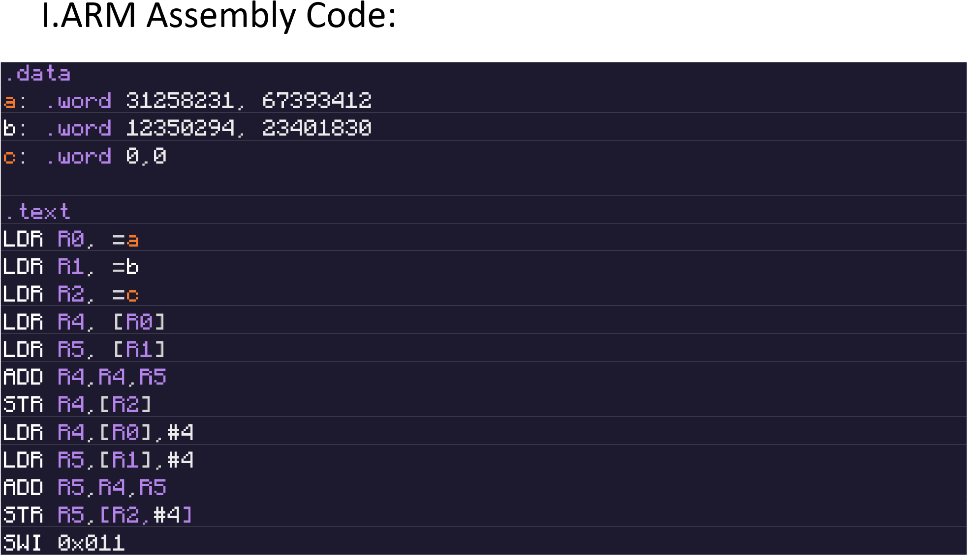

II. Output Screen Shot (One):

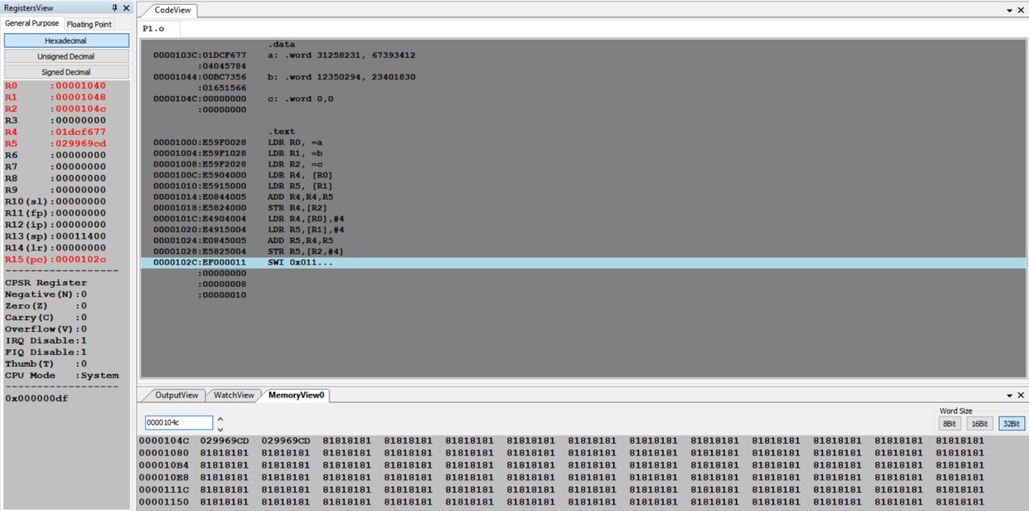

Date: 13/02/23

|  |  |  |
| --- | --- | --- |
| Name: Nikhil Girish | SRN:  PES2UG21CS334 | Section: F |

Week#____4_______ Program Number: ____2___

Title of the Program

**Write an ALP to find 1’s and 2’s complement of a 32 bit number**

I.

ARM Assembly Code

:



II. Output Screen Shot (One)

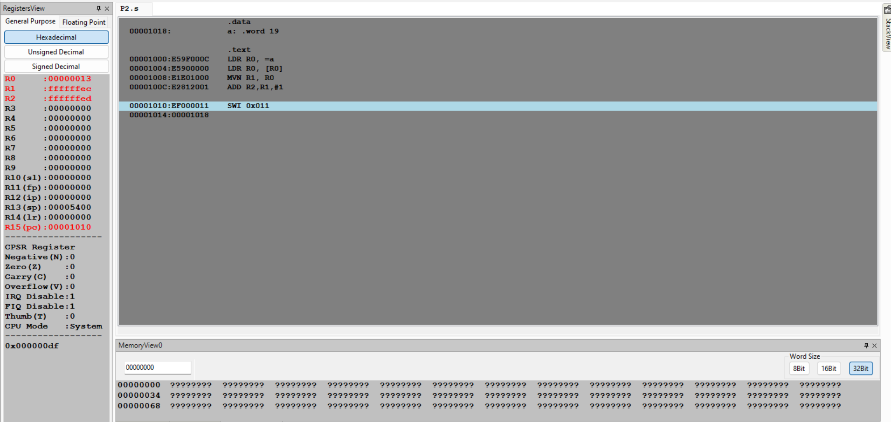

Date: 13/02/23

|  |  |  |
| --- | --- | --- |
| Name: Nikhil Girish | SRN:  PES2UG21CS334 | Section: F |

Week#____4_______ Program Number: ____3 __

Title of the Program

**Write an ALP to scan a 32 bit number if it is negative or positive**

1. ARM Code:

.data

a: .word 20

p: .ASCIZ "positive"

n: .ASCIZ "negative"

.text

LDR R1,=a

LDR R2,[R1]

CMP R2, #0

BLT min

LDR R0, =p

B END

min:

    LDR R0, =n

END:

    SWI 0x02

    SWI 0x11

    .end

1. Output Screen Shot (One) :

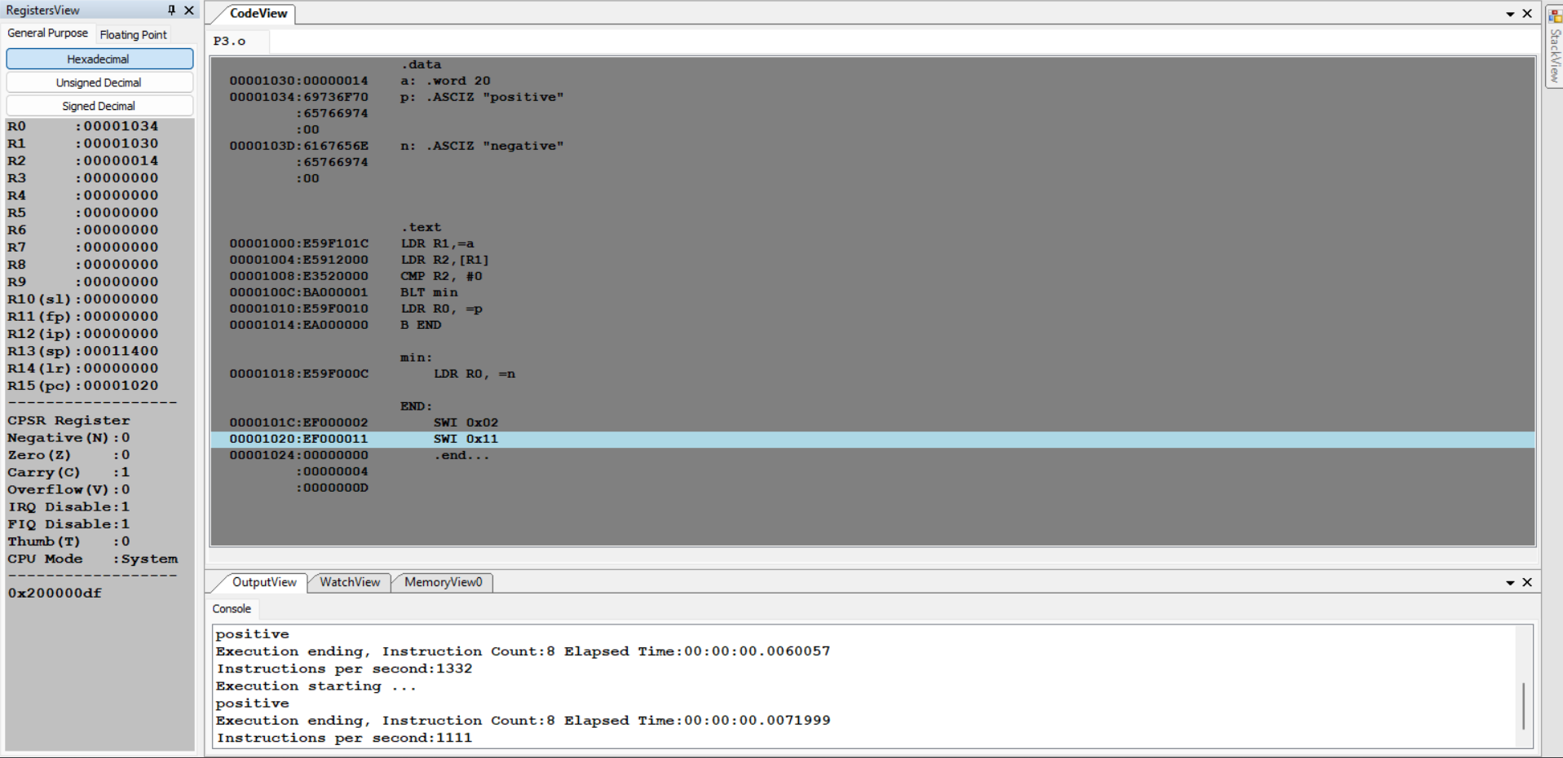 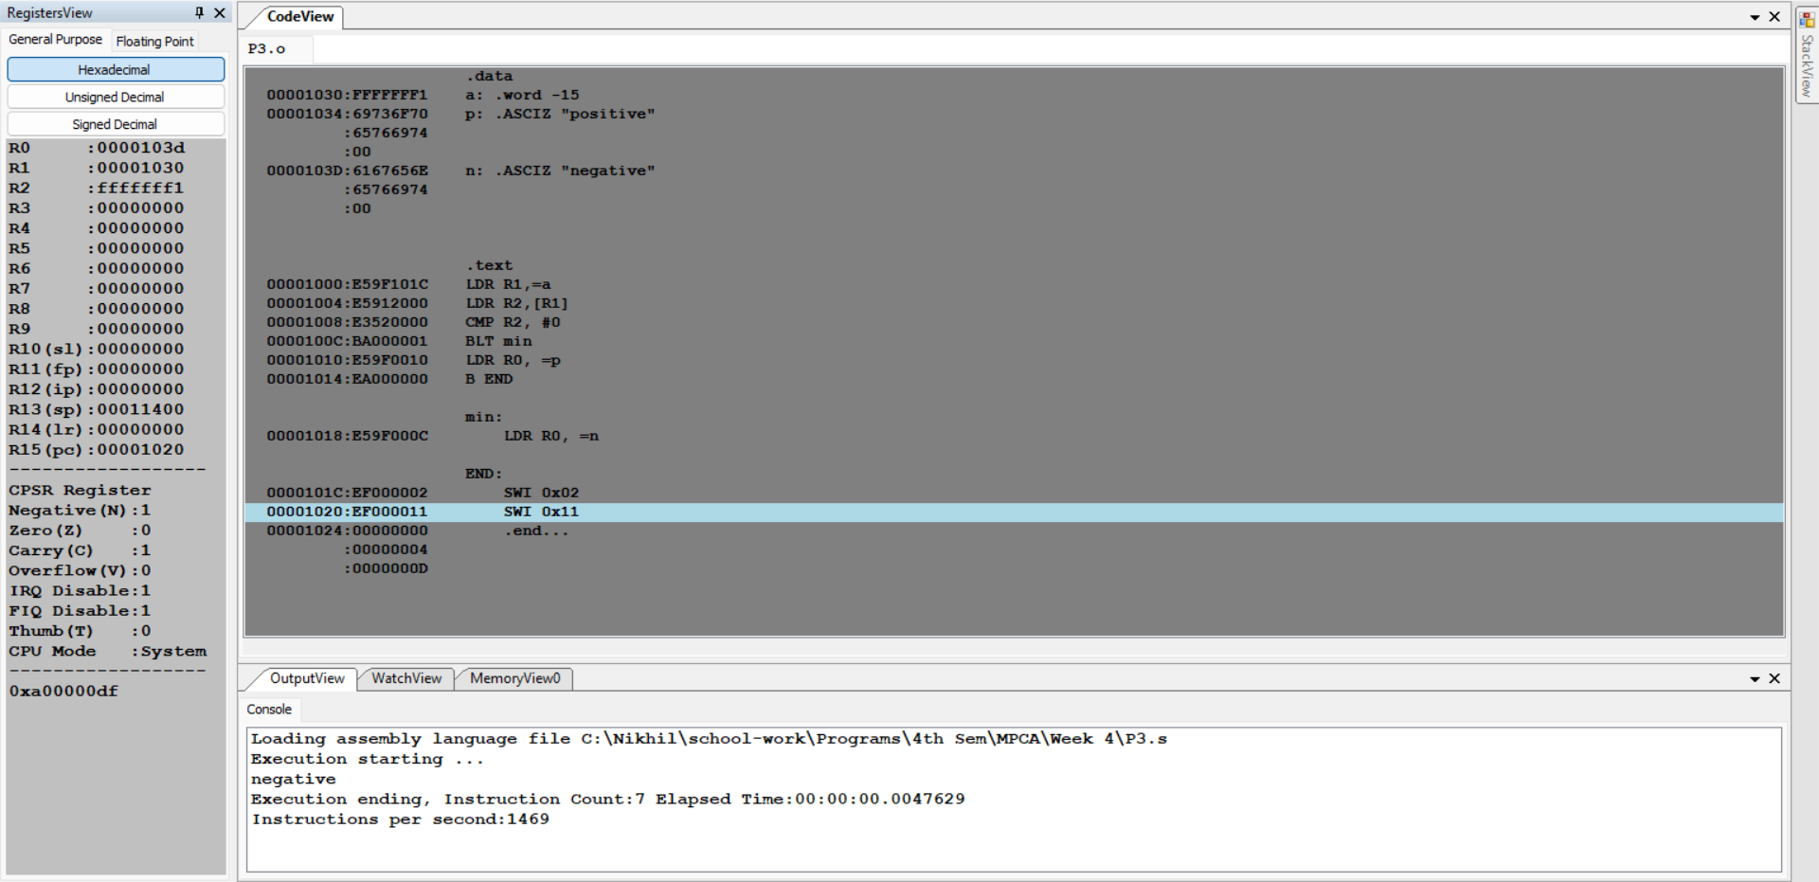

Date: 13/02/23

|  |  |  |
| --- | --- | --- |
| Name: Nikhil Girish | SRN:  PES2UG21CS334 | Section: F |

Week#____4_______ Program Number: ____4__

Title of the Program

**Write an ALP to find the number of zeroes, positive and negative numbers in a given array**

1. ARM Code:

.data

arr: .word 0,3,-1,6,3,9,-4,-2,1,0

.text

LDR R0,=arr

MOV R1,#0

MOV R2,#0

MOV R3,#0

MOV R4,#0

MOV R5,#0

START:

    CMP R2,#10

    BEQ END

    LDR R1,[R0,R2,LSL#2]

    CMP R1,#0

    ADDEQ R3,R3,#1

    ADDGT R4,R4,#1

    ADDMI R5,R5,#1

    ADD R2,R2,#1

    B START

END:

    MOV R1,#0

    MOV R2,#0

    SWI 0x011

1. Output View:

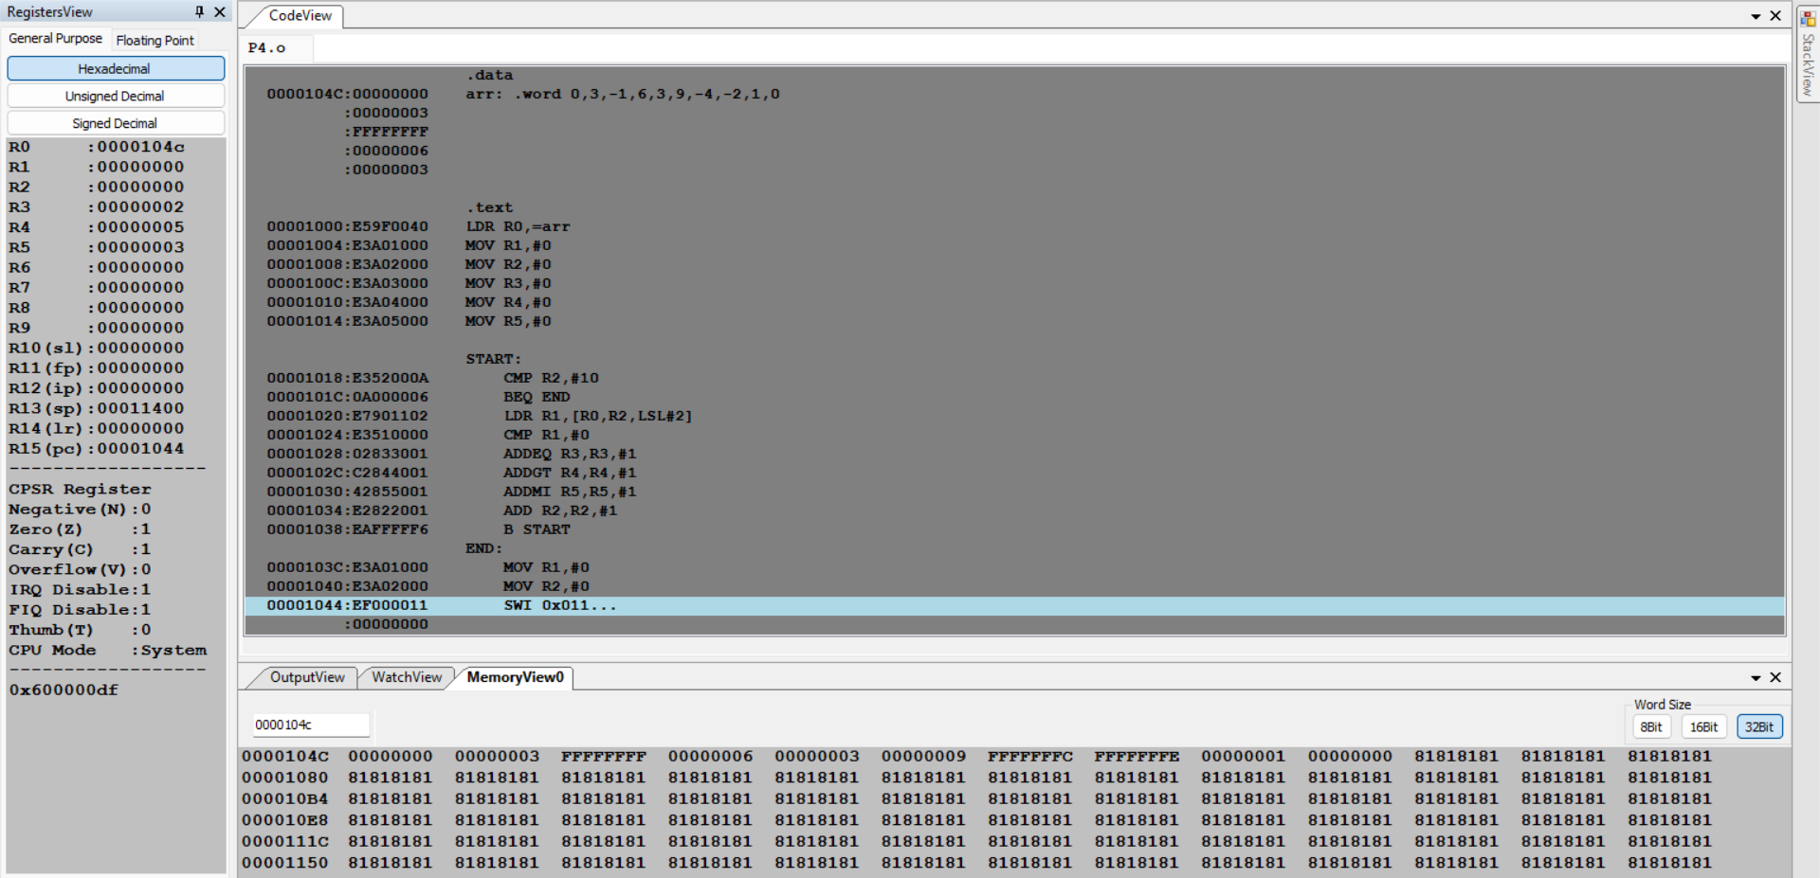

Date:13/02/23

|  |  |  |
| --- | --- | --- |
| Name: Nikhil Girish | SRN:  PES2UG21CS334 | Section: F |

Week#____4_______ Program Number: ____5__

Title of the Program

**Write an ALP to count the number of 1’s and 0’s in a given 32 bit number.**

1. ARM Code:

.data

a: .word 11

ODD: .ASCIZ "Odd Parity"

EVEN: .ASCIZ "Even Parity"

.text

LDR R0,=a

LDR R0,[R0]

MOV R1,#0

MOV R2,#0

MOV R3,#0

MOV R4,#0

START:

    CMP R3,#32

    BEQ END

    TST R0,#1

    BEQ ZERO

    ADD R2,R2,#1

    B CONTINUE

ZERO:

    ADD R1,R1,#1

CONTINUE:

    MOV R0,R0,LSR#1

    ADD R3,R3,#1

    B START

END:

    TST R2, #1

    LDREQ R0, =EVEN

    LDRNE R0, =ODD

    MOV R3,#0

    MOV R4,#0

    SWI 0x02

    SWI 0x11

1. Output Screen Shot (One):

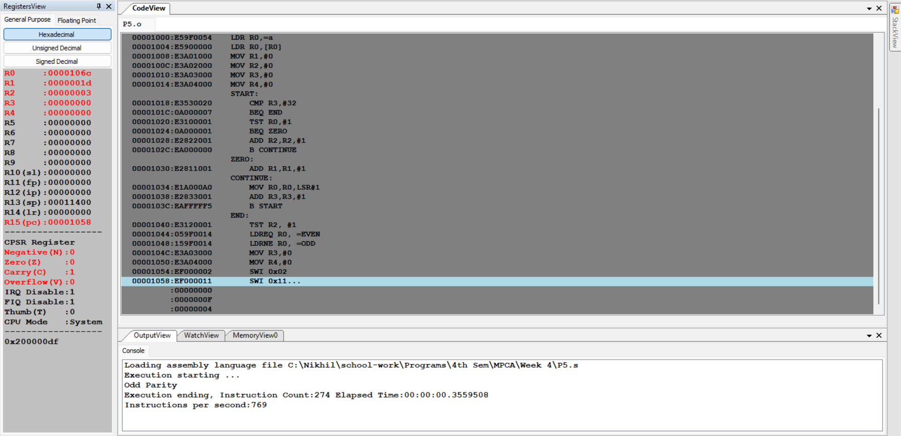 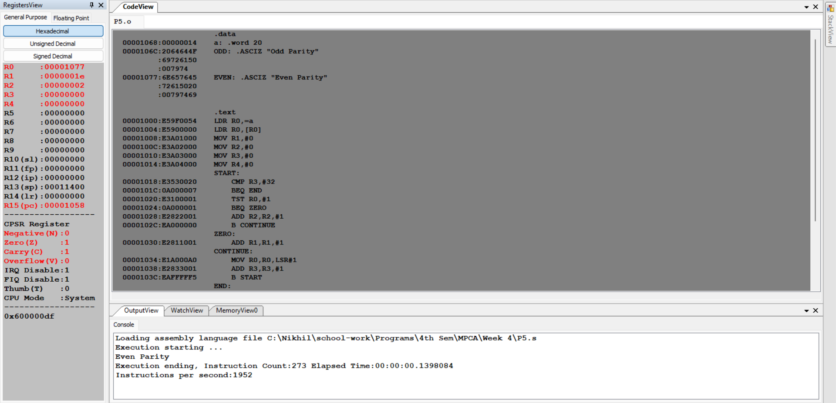

**Microprocessor and Computer Architecture**

**UE21CS251B**

**4th Semester, Academic Year 2022-23**

Date: 13/02/23

|  |  |  |
| --- | --- | --- |
| Name: Nikhil Girish | SRN:  PES2UG21CS334 | Section: F |

Week#____4_______ Program Number: ____6__

Title of the Program

**Write an ALP to check the given number has odd or even number of 1’s and display the result. (Even Parity and Odd Parity)**

1. ARM Code:

.data

a: .word 69

odd: .asciz "ODD PARITY"

even: .asciz "EVEN PARIRY"

.text

LDR R0,=a

LDR R0,[R0]

MOV R1,#0

MOV R2,#0

MOV R3,#0

MOV R4,#0

START:

    cmp R3,#32

    BEQ END

    TST R0,#1

    BEQ CONTINUE

    ADD R2,R2,#1

CONTINUE:

    MOV R0,R0,LSR#1

    ADD R3,R3,#1

    B START

EVEN:

    LDR R0,=even

    SWI 0x02

    SWI 0x011

END:

    MOV R3,#0

    MOV R4,#0

    TST R2,#1

    BEQ EVEN

    LDR R0,=odd

    SWI 0x02

    SWI 0x011

1. Output Screen Shot (One):

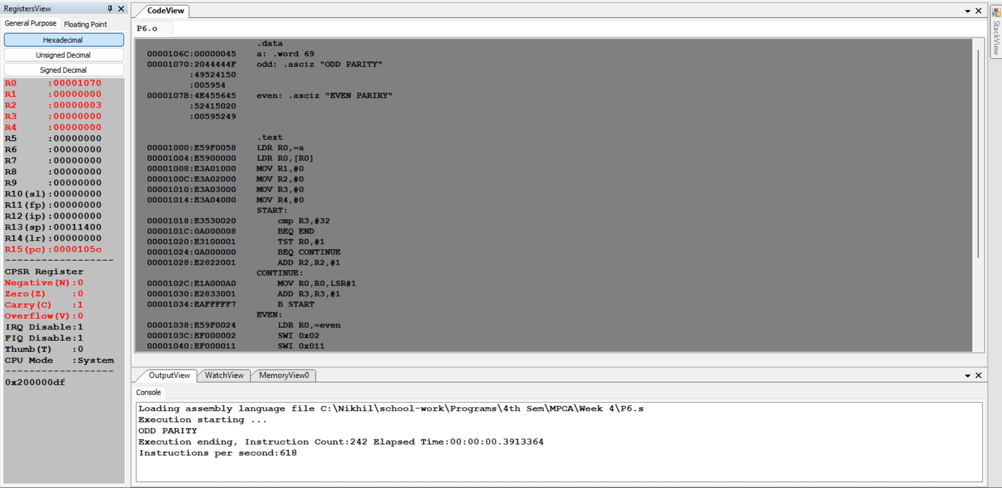



**Disclaimer:**

* The programs and output submitted is duly written, verified and executed by me. I have not copied from any of my peers nor from the external resource such as internet.
* If found plagiarized, I will abide with the disciplinary action of the University.

Signature: Nikhil Girish

Name: Nikhil Girish

SRN: PES2UG21CS334

Section: 4F

Date: 13/02/23